Paintings in the Style of a Famous Artist
The artist I chose to research is Katsushika Hokusai. He was born on October 31, 1760 and he died on May 10, 1849. Hokusai was a famous artist during the Tokugawa Shogunate of the Edo period in Japan. Most of his greatest artworks were completed between 1820 and 1840. He specialized in fine art painting and Ukiyo-e woodblock prints. Hokusai is considered to be one of Japan’s best landscape artists, but he also painted portraits and illustrated books as well. Hokusai’s art spread to 19th century Europe as a result of Japonism, a time in late 19th century Europe when Japanese art influenced European works. His artwork influenced French painting, especially Claude Monet’s.
Hokusai started painting when he was just six years old when his father taught him. His father painted decorative designs on mirrors and their frames for a living. From 1774 to 1778 Hokusai was apprenticed to a master of wood-carving. When he was eighteen, he began serious training in print design under someone named Katsukawa Shunsho. Katsukawa Shunsho was the leader of the Katsukawa school. Hokusai illustrated books and created prints with beautiful women on them under the name Shunsho. In 1795, two years after his teacher died, Hokusai left the Katsukawa school to explore other styles of painting. He studied Dutch Baroque copperplate prints by French Baroque artists. He began painting landscapes and genre painting, pictures depicting situations and scenes of everyday life. In that same year he began associating with the Tawaraya School. He produced numerous brush paintings called surimono as well as various types of illustrations for poetry books and calendars. He also produced a series of of beautiful women, bijinga. Hokusai changed his artist name about twenty times before he adopted the name Katsushika Hokusai in 1798. Hokusai decided to start up as an independent painter and printmaker shortly before using his new name. Over the next twenty years, Hokusai became known as one Japan’s most innovative artists.
One of Hokusai’s most famous paintings is called The Great Wave. It was completed in the year 1832. He choose to do a polychrome woodblock print for this project, made of ink and color on paper. It is about 10 by 14 inches. The Great Wave was created as part of a larger series of woodblock prints called Thirty-six Views of Mount Fuji. All of the pieces in the series include the mountain, but it doesn't always take up most of the picture. Hokusai chose to have the mountain smaller in the background to make it seem like the huge wave was going to swallow it up. He arranged the composition of this artwork to to frame Mount Fuji. The wave symbolizes the unpredictability of life and the great force of nature, and the mountain symbolizes stillness and eternity.
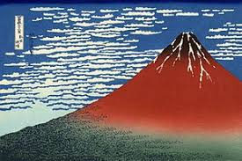
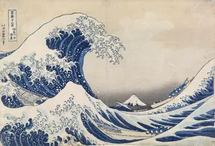
Another piece from the series Thirty-six Views of Mount Fuji is called Fine Wind, Clear Morning. It was created by Hokusai around 1832. This artwork is a color woodblock print that is about 10 by 15 inches. This print of Mount Fuji was made in early Autumn. Mount Fuji looks red at this time because of the early Autumn sun. He painted the sky a deep blue with scattered white clouds. At the top of the mountain, you can see remnants of snow. At the bottom there are dark shadows from the forest. The mountain is clearly the main focus in this woodblock, unlike in The Great Wave where the wave overshadowed the mountain.

Bibliography
http://www.visual-arts-cork.com/famous-artists/hokusai.htm
https://theculturetrip.com/asia/japan/articles/hokusai-s-great-wave/
http://japaneseprints.org/hokusai/fine-wind-clear-morning/

